HUMAN TRAFFICKING IN UNITED ARAB EMIRATES: FORCED LABOUR
Name
Student No.

A research project submitted to the department of ……………., in partial fulfillment of for the award of …………………..in the University of ………….

CHAPTER THREE; RESEARCH METHODOLOGY

Introduction
This section will look at the research methodology to gain on the aspect of human trafficking so that more efficient methods and policies that can be developed to eliminate the practices of human trafficking and consequently forced labor in the United Arab Emirates by attempting to identify the factors that lead to human trafficking and related forced labor and suitable policies and prevention methods that can be used in the United Arab Emirates to prevents the cases of forced labor and the impacts of worker immigration into United Arab Emirates increasing social impacts, economic impacts and most importantly environmental impacts.
Research methodology is a very critical part of the research. It is the science of how the research is to be carried out. It is the outline of the process that is used to collect the data and information purposed to make the analyses of the research hypothesis and research question as to provide results that will be used to make decisions and implement future studies on the particular subject (Kothari, 2004). More often than not the research methodology is suited to the needs of the researcher elaborating the specification and limitations that the researcher had to overcome to successfully research at hand. While the various procedures, schemes and algorithms used in research methodology is a science of studying how research is to be carried out. The research methods used b the researcher during the research period are essentially planned, scientific and value-neutral (Kothari, 2004). The research methodology, on the other hand, gives the procedures by which the researcher has carried out his study though explaining, describing and predicting the phenomena that are the subject of the study. The research methodology defines the processes that the knowledge about the subject is gained. It provides the working plan of the research (Kumar, & Phrommathed, 2005).
It is important that the researcher understand not only the methods of research necessary for the It is necessary that the researcher designs the methodology for the problem they have selected. One should take careful note that even though the method considered in two different problems may be similar, the methodology may vary. It is essential that the researcher gets to realize that the research methods that put to the utility under the research are very necessary to have in a bid to achieve their objectives (Kumar, & Phrommathed, 2005).
The researcher, for example, will have to calculate the variance the mean and the distribution of the set of data that they will use as their sample population. They also should be aware on how to graph the data results they get, how to determine the algebraic roots of their data, how to make an application of their knowledge on particular statistical aspects to evaluate the data they will collect in the field. It will also be of significant contribution to their research if the researcher knows how to find a solution of a physical system as described by a mathematical model (Marczyk, DeMatteo, & Festinger, 2005). The researcher will also be able to give the expected accurate and reliable results if they are aware of;
• Which method is suitable for the design that they choose to employ in their research?
• What is the measure of the accuracy of the result of the method they will employ?
• What is the relative efficiency of the method they have utilized in the research?
• What is the reliability of this method to the application in the research?
• Is the method that has been selected valid for the research study?
It will consider the research methods used in the data collection, which will be carried out under the following headings: study design which indicates the design to used and the reasons as to why it is selected, their totals and their percentages, sample design which shows the same categories as the targeted population and a ratio that is used for research. Data collection technique, which shows the data collection instruments and the reason they were chosen and the data collection analysis and data procedures, which shows how the collected data will be compiled to make a common meaning. The chapter will also discuss the privacy and ethics, and reliability of the information gathered (Kumar, & Phrommathed, 2005).
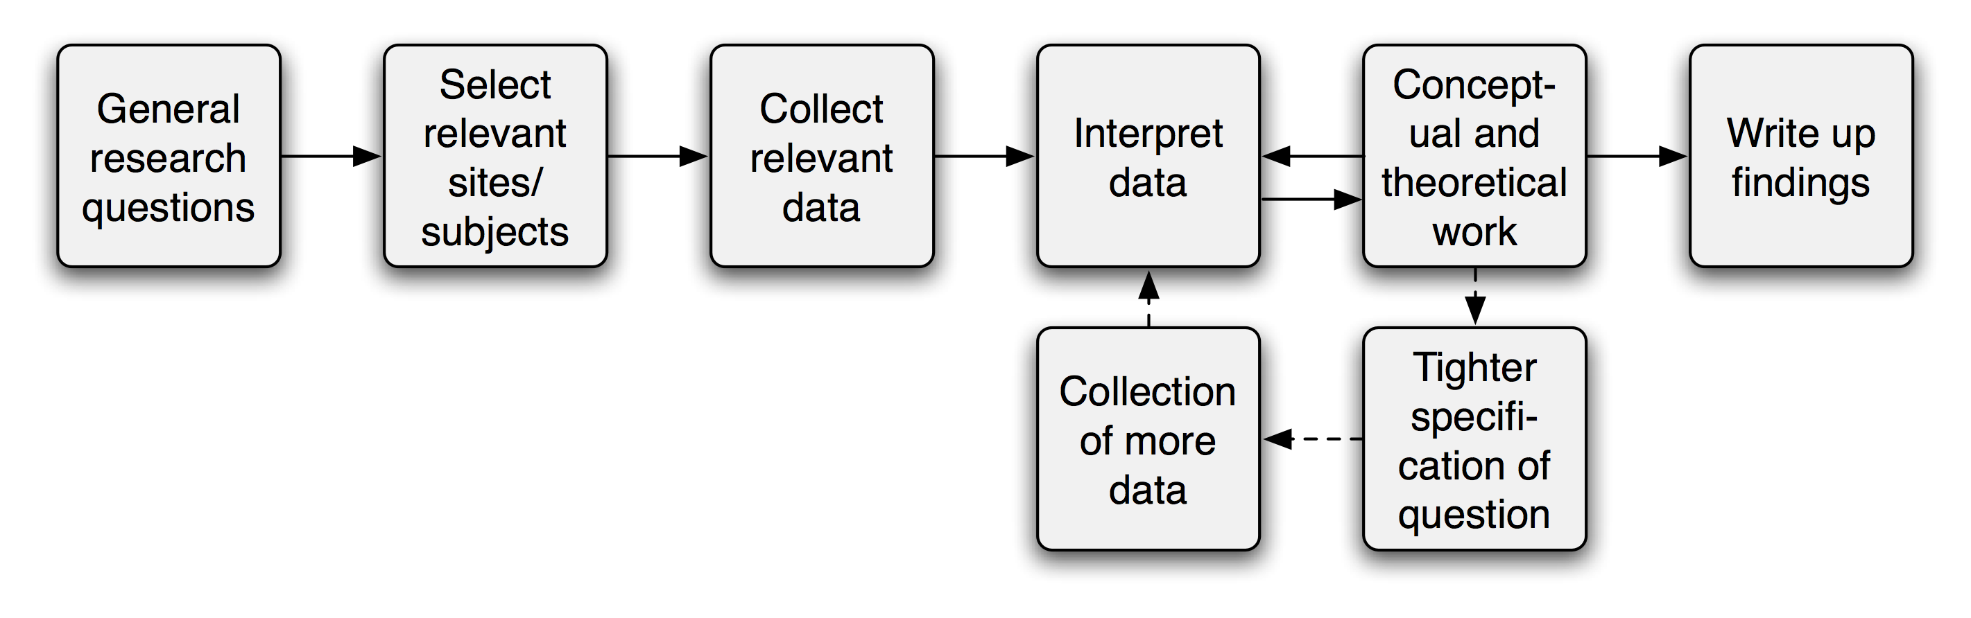

Research Design
A research design is a plan, the strategy or the structure that can be implemented under the investigation conceived in research to obtain the solution to the posed research question or the hypotheses formulated in a bid to prove it right or wrong (Kothari, 2004). The designed plan will be in tandem with the complete programme or the research scheme. In the research design includes the research outline which is the gist what the researcher will do in the period of the research. It will cover the writing of the hypotheses to the operation of the implications of the hypotheses and finally the data analysis of the record collection in the field during the period of the research.

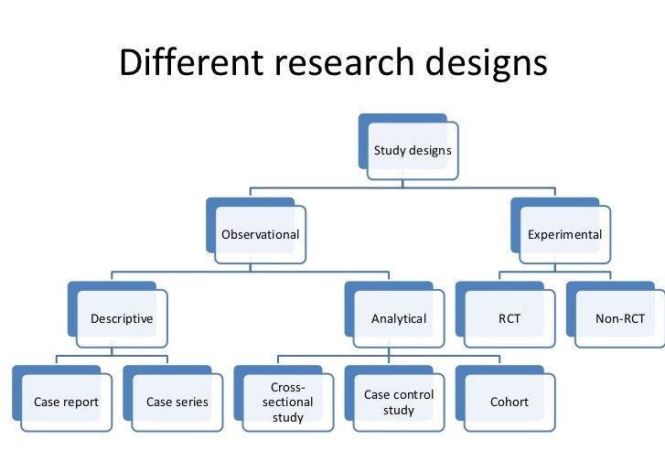
Traditionally the research design held the blueprint of the detailed plan of the study to be conducted for the research question. It shows the life period of the research and how it will be completed. It depicts the operationalization variables, so they put to measurement. It will also the collection of the sample of the study and the collection of the data to be utilized and the foundation of the tests that will be done on the hypotheses created or the subject research question and the analysis of the outcomes, the results of the data collected (Marczyk, DeMatteo, & Festinger, 2005). The research design is defined as a procedural plan that gets adopted by the investigator or rather the researcher will be utilised to answer the research question and test the hypotheses created by the research validly, economically, accurately and most importantly, objectively.

Another way of perceiving the research design is approaching it as the arrangement of the conditions and the environment conducive enough for collection of the data and its consequential analysis in a way that intends to bring together the relevance of the research purpose and the economy of the procedure that will be followed to fulfil the objective of the research study (Marczyk, DeMatteo, & Festinger, 2005). The research design helps the researcher decide the direction that they will embark on in communicating with the participants in the research. the
It will help the researcher decide on how they will also communicate their decision to their audience about the subject under study and the research design that has been employed in conducting the research study. The research design also comes in handy in the dissemination of the information on the procedure that will be used by the researcher in coming up with devices to collect data for the participants to research or the sample taken for the field into a research laboratory.

The same is also depicted on the methods that are used by the research to come with the tools to analyse the data they have collected and how they will display or rather present the analysis tests and the outcome of the hypotheses tests (Kumar, & Phrommathed, 2005). Additionally, the research design also assists the research to develop the solution to the needs to detail the research design rationale and the justification of every decision that will be used the research to come up with the answer the how, the methodology of the research journey. While making the presentation of the justification and the rationale of the research design methods, there needs to be strong support with critical elaborations from the literature reviewed. The researcher needs to have assurance and also assure others of the validly and reliability of the paths that will be taken by the researcher in conducting the study.

The research design functions to create the clarity of the methods utilized to undertake the research study. There are two main functions of the research design. The first function is the relation of identification or rather the development of the logistical arrangements and the procedures that are a requirement for the study to be undertaken. The second function is to make an emphasis on the impotence of nature and the quality of the procedures that have been utilised to ensure the accuracy, objectivity reliability objectivity of the results of the research study. The research design, therefore, helps the researcher to;
• Conceptualise the operation of the plan to undertake the various procedures and task that are a requirement for the completion of the study.
• Ensure that the particular procedures utilised in the research to derive accurate and very objective answers to the research question are adequate for the same purpose.
The research designs should be detailed for the benefit of both the supervisor and the researcher. It should be able to be able to satisfy the entre that will use the research study and make an application for it. It should clearly depict the procedures that had been planned by the researcher to obtain answers to researcher’s questions and formulated hypotheses (Marczyk, DeMatteo, & Festinger, 2005). The most important objective of research design is to clearly specify every procedure of the research and all the analyses activities s that the readers or rather the audience of the research can comprehend all the specification of the researcher and can replicate them. It is clear therefore that the research design should be able to do the following;
• Name the study design that was utilised per se. It should point out whether the research was cross-sectional, comparative, control experiment, random control, or before and after research.
• It should provide the detailed specification on the following aspects;
- What or rather who will constitute the targeted research population?
- What pointers would be used to identify the research population?
- Will the study populate only consist of only a sample of the population or the whole population?
- What communication method be used to reach or contact the sample population?
- How will the researcher acquire consent to use the sample population for analysis of the hypotheses or research question of their study?
- What will be utilised as the method of data collection and what purposed the selection of that method?
- How will the ethical issues arising from the research conduct be dressed?
- In the case that a questionnaire utilised as a tool for data collection how will the respondents return the filled questionnaire to the researcher?
- In the case that the researcher uses an interview as a tool for collecting the information for the research, where will the interview with respondents be conducted?
- How will the ethical issues arising from the research conduct be dressed?
- In the case that a questionnaire utilised as a toll of data collection how will the respondents return the filled questionnaire to the researcher?
- In the case that the researcher uses an interview as a tool of collecting the information for the research, where will the interview with respondents be conducted?

Change in the
Dependent
Variables
Change because of
Independent
Variables
Change because of
Extraneous
Variables
Change because of
Chance

The factors that will be accounted for in the research to bring about the effect on the desired results are called the variables of the study. The virile are either dependent or independent. The dependent a variable are the factors that are influenced by the conditions or environment set to determine a thesis or answer a research question. These set of conditions are called the independent variables. The changes in the dependent variable that are affected by the independent variables are named as the random variable or rather the chance variables. These, in turn, make up the results that are analysed to answer the research question and achieve the research objective or prove a hypothesis true or false.

The researcher will use a detailed survey and in particular case study model. The case study model is described by Kumar (2005) & Phrommathed, (2005)as a comprehensive study of a social unit, be it a person, a group, a social institution, a district or community. The descriptive research design is also useful because the respondents are given time to respond without any interference and manipulation, and the information given is detailed and obtained much faster. The below shows proportions of different units who responded to the questionnaires.

The population of the Study.
The population of the study refers to the total number of elements in the study (Kumar, & Phrommathed, 2005). In the case of this research, the population targets about two hundred respondents in the United Arab Emirates. The population would be picked form the migration officers, willing victims of the human trafficking acts in the United Arab Emirates officials from the labour industry in the United Arab Emirates and also respondents from the construction industry in the United Arab Emirates. The researcher will also approach respondents form the Human rights offices in the United Arab Emirates. Since it is practically not possible to collect data from all victims of the human trafficking activities in United Arab Emirates and the fact that the sample population is way smaller than the real population the representative sample of respondents for the United Ara Emirates will be selected randomly from the different emirates in the United Arab Emirates, and they will be stratified by all categories to represent the population.

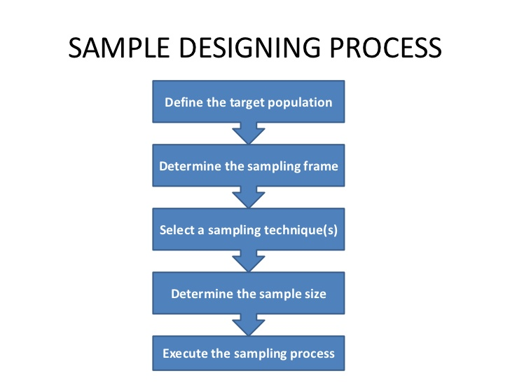

Sample Design.
Sample design refers to the technique used to select a smaller group of the entire population to represent the whole population. Since the population targeted by the researcher is relatively large and the time for study is not enough, a sample of the respondents both male and female from all categories will be selected randomly when distributing the questionnaires; stratified sampling techniques will be used. Then the respondents from the United Arab Emirates will be divided into strata’s, and the results gained will represent the views of the students in the whole institution. The researcher considers stratified technique the best in that it holds the following advantages: less time since it is not the entire population, but a fraction, of it, is investigated. It is economical since there is a reduction in cost, working hours needed to perform the research; efficient since the population in the research is heterogeneous, and reviews from different categories will be evaluated.

Element Selection Technique

Unrestricted Sampling
Element Selection Technique  Unrestricted Sampling | Probability Sampling | Non-Probability Sampling
Restricted Sampling | Simple Random Sampling | Haphazard/Convenience Sampling
Restricted Sampling | Complex Random Sampling | Purposive Sampling

Data Collection Instruments.
Both structured and unstructured questionnaires will be designed to collect data. This method is suitable as it provides for quantitative data requirement.
Questionnaires.
Questionnaires will be designed, pre-tested before the actual exercise and embarked on. Structured questionnaires are instruments designed to provide short answers or responses from the respondents. Questionnaires have the advantage of encouraging high response rate providing data which are easy to organize tabulate and analyse statistically, which are objective. That is all respondents provide answers in the same way. The questions in this section were able to facilitate identification of respondents who use the World Wide Web (WWW) and queried sites used and preferred site characteristics (Marczyk, DeMatteo, & Festinger, 2005). They have the disadvantage limiting the amount of information the respondent is capable of providing.
The questionnaires what will be used will have both res and the unstructured for so questionnaire. They will contain the closed questions and the open-ended questions. The closed question will be used to limit the question that the research needs particular answer specifically making a comparison and having choices to selected later in the analysis. The closed question guide the respondents toward the particular answers that the researcher is looking to analyse. They give a boundary to the nature of answers that the respondents are allowed to provide. The open-ended questions, on the other hand, will be used to allow the respondents to give their own opinion on the question that the researcher will use to measure the correlation of the respondents that will be collected to ensure that the data s reliable and dependable for that matter (Kothari, 2004).
Data collection procedure.
Method of data collection on that is used by most research and scholars are can be used both in the quantitative and qualitative research types. The distinction that occurs between the two types of researches is mainly the imposition of restrictions in ta he collection of data, their flexibility, the structure that will be adhered to during the research and the collection of data, depth of the research and, sequential order of the reach content and the freedom that the researcher has at their disposal during their research processes (Marczyk, DeMatteo, & Festinger, 2005). The method of data collection is classified with regard to the following;
• What is the philosophical epistemology that particularly underpins the approach that the researcher has applied in their research inquiry?
• In what way was the information for the research gathered?
• Was the information collected through unstructured and flexible format or rather a structured and rigid format of a collection of data?
• Were the issue or the questions discussed during the collection of the data predetermined by the researcher or were they randomly developed during the process of data collection?
• How was the information collected kept in records? Was the method of record considering descriptive data, categorical data, and narrative data or rather a quantitative form of data or scaled data?
• What devices were used for the analysis of the data? Was the analysis descriptive numerical, graphical, or categorical in nature?
The researcher will use both primary data that is the one collected from the target population by use of questionnaires and observation and secondary data that is from university records, newsletters, and journals. Prior to the conduction of the study, the student will test the quality of instruments by conducting a pilot study on about ten respondents from all categories.

Data Analysis.
Descriptive statistics, such as pie charts and bar charts, will be used in the analysis of the data collected. This way of analysing research details is convenient as the methods are simple and standard procedures and are easy to understand. The data collected will be processed by editing, coding, classifying, feeding in tables and use of graphs and pie charts. Analyses of data in the study will include both qualitative and quantitative analysis (Newman, & Benz, 1998). Qualitative analysis will include giving explanation, understanding and interpretation of situations and people based on the data collected. It gives insights into a problem or helps to develop ideas or hypotheses for potential research. Quantitative analysis involves numerical analysis of data collected through a questionnaire (Newman & Benz, 1998).The information will be systematically analysed to come up with useful and consequential or important conclusions of measures or sources needed to be expressively described using statistics or indices

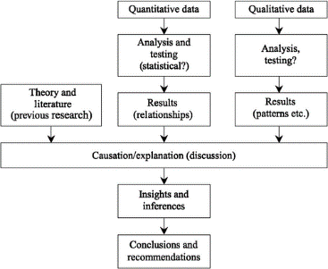

Privacy and Ethics
All the profession that one may think of usually guides by the code of ethics developed and designed to suit the profession and its operations. The evolution of ethics over the years has come to accommodate the change in needs, values, expectation and ethos of the parties that had a stake in the particular professions. These professions also have a general code of conduct that ovens the way the professionals are expected to behave in their occupations. These codes, the code of ethics and the code of conducts guide the way the researchers are undertaken in these particular professions and fields of interest (Marczyk, DeMatteo, & Festinger, 2005). Ethics can be defined as the expecting exerted by the social organization on individuals to act in accordance with the principles of the conducted set and considered to be the right way to carry oneself. These are accorded especially to the social groups that are professional.

The ways each profession is serving the society changes continuously with the needs of the society and the society’s expectations. The ethical codes that govern the manner in which the researchers also have to change to adjust to the needs of the professions. Any practice that the may be judged in the research will be made by the code of ethics and code of conduct both prevalent and relevant that the time of practice and place of practice (Kothari, 2004). The manner that the practice is judged to depend on the applicant of section behaviours in research such as the cause of harm to the respondent or to a particular group of individual animals plants or organisms, breach of confidentiality of the respondents and improper use of both personal information and information gathered for respondents. These activities in research are considered unethical and should be avoided by all means.

Privacy and ethics of the study will be ensured through obtaining voluntary consent of the participants. This will ensure that the research assistant does not fill being forced to undertake the task. Research respondents will be assured of their autonomy as no preconditions on matters of who they should share the information with the study. In the questionnaires, the respondents will not write their names. Permission will be sought to form every institution administration that will be involved in the research before distribution of the questionnaires. The information obtained from the respondents will be protected in that; it will not be disclosed to unauthorized personnel. It is purely for research purpose.

Validity and Reliability.
Reliability could best be described as the levels of consistency and stability of the results produced by the assessment tool. The reliability of this research was tested by comparing the responses in the pilot questionnaires with the real ones (Kothari, 2004). To test the validity of the measure, the study will check whether our respondents ‘self-reports reflected other behavioural characteristics consistent with dependency and heavier use. For some of these analyses, data will be grouped to form a human trafficking victims group and non-victims of the human trafficking group
..

Reference
Kothari, C. R. (2004). Research methodology: Methods and techniques. New Age International.
Kumar, S., & Phrommathed, P. (2005). Research methodology(pp. 43-50). Springer US.
Marczyk, G., DeMatteo, D., & Festinger, D. (2005). Essentials of research design and methodology. John Wiley & Sons Inc.
Newman, I., & Benz, C. R. (1998). Qualitative-quantitative research methodology: Exploring the interactive continuum. SIU Press.

